AASHUTOSH MISHRA
1NT22CS002

LAB CODES:

SBT file running:

code:
import org.apache.spark.sql.SparkSession

object WordCountApp {
def main(args: Array[String]): Unit = {
val spark = SparkSession.builder()
.appName("WordCount")
.master("local[*]")
.getOrCreate()

val sc = spark.sparkContext

val lines = sc.textFile("text.txt")

val wordCounts = lines
.flatMap(_.toLowerCase.split("\\W+"))
.filter(_.nonEmpty)
.map(word => (word, 1))
.reduceByKey(_ + _)

wordCounts.saveAsTextFile("word_count_output")

println("Words occurring more than 4 times:")
val frequentWords = wordCounts.filter(_._2 > 4)
frequentWords.collect().foreach { case (word, count) =>
println(s"$word: $count")
}

spark.stop()
}
}
output:
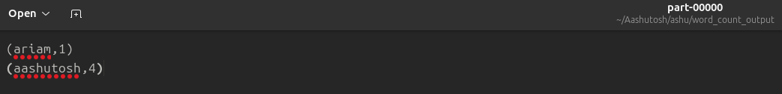
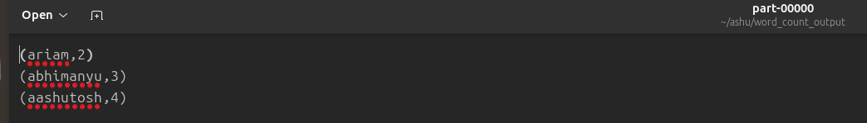

// sbt file:

name := "WordCountApp"

version := "0.1"

scalaVersion := "2.12.18" // Make sure you're using Scala 2.12.x

libraryDependencies += "org.apache.spark" %% "spark-core" % "3.5.0" // Adjust Spark version if needed
libraryDependencies += "org.apache.spark" %% "spark-sql" % "3.5.0"

